**Course: Advance Bio Informatics**

**Module Title: PhyloBLAST**

**Module No: 61**

Internet accessed application based on CGI/Perl programming.

Compares users protein sequences to SwissProt/TREMBL DB

**Features:**

* Evolutionary relationship of proteins
* organism or gene information can be added to BLAST output
* Selection/ modification of High scoring pair segments for further
* Processing
* Email facility for time saving
* Tree as either tree file, graphic or ASCII text based tree,
* Hyperlinks for further information about the sequences

**Working**

It is very simple to operate. Working starts by opening the webpage, i.e. the user pastes protein sequences in the box. Comparison with in house DB is performed for the input sequence. Output for BLAST is produced. Finally pair wise phylogentic distance between user sequence and hit sequences is measured.

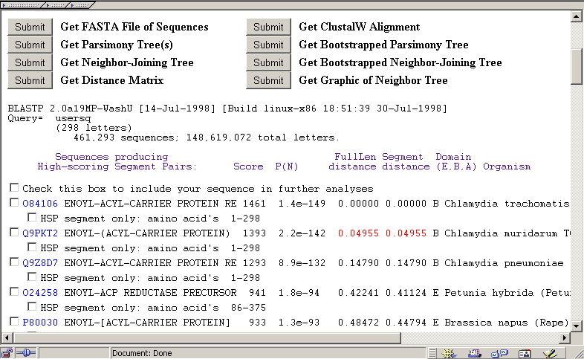

**Enhanced Features**

It is better than plain BLAST since it generates enhanced output than

BLAST such as graphical display, description of organism and gene name,

eukaryote/bacteria/archaea membership information.